Opportunity Scholarship Program
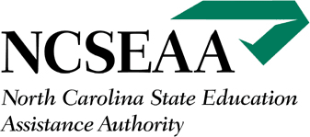
www.ncseaa.edu

- Provides scholarships for up to $4,200 per student per year
($2,100 dollars per student per semester) and covers tuition & fees
- For students who would attend a NC public school or will attend one the Spring semester before the scholarship will begin
- There are exceptions including rising kindergarteners and rising first graders. This is an excellent opportunity to engage your Pre-K and Kindergarten parents. Don’t let them miss out! Families must meet the income requirements for this program

NOTE: Income eligibility has changed for the 2021-2022 school year. More families with higher incomes may be eligible.

Children With Disabilities Grant
- Provides up to $8,000 per student per year and covers tuition and fees at a private school and/or qualified expenses related to educating a child with a disability
- Tuition can be paid to your school directly and qualified expenses are reimbursed to the family
- For students who have a NC IEP dated within the last 3 years

Education Savings Account
- Provides up to $9,000 per student per year and covers tuition and fees at a private school and/or qualified expenses related to educating a child with a disability
- Families provided an electronic account to pay tuition and expenses
- For students who have a NC IEP dated within the last 3 years

For more information, visit EXCEPTIONALEDNC.ORG

